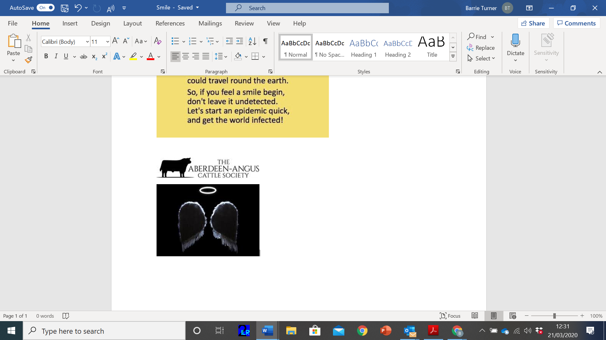

Help is at hand - call an Aberdeen-Angus Angel

In the light of the recent outbreak of COVID-19 and its anticipated spread we believe the colleges are closed for an elongated break and rather than waste the talent that may well be out there we as a Society are looking to set up a national network of Stock people who could step in to help any farms who find themselves short of labour through self-isolation or family tragedy which it is anticipated there might be some.

Farms and livestock don’t stop needing attention particularly at this time of year for lambing calving etc. We are hoping that by using the resource of Students being off, College, shows being cancelled and Stock people possibly available with time on their hands there may be an opportunity to step in short term to help anyone who finds themselves in need of an extra skilled pair of hands on the farm.

We feel that this resource may prevent or help to prevent any animal welfare issues that may arise out of labour shortage on farms, where the labour element has already been reduced as far as it can be for economic reasons.

We see that tying the two together in a central point, people who need skills and labour and people with those skills some much needed funds, it’s a perfect marriage. Once up and running it is a resource that can be kept going.

We will be setting up a section on our website where willing and available stock people in need of some work and experience, could post their CV and so that members and others could see their availability and the area where they are located and draw on the resource if needed.

We would call the group The Aberdeen-Angus Angels! It would be a nationwide network, available to step in a help anyone in need. Register your interest today and encourage your friends to join the Angels and we can team together to help the livestock sector through what is going to be some difficult times.

Send your CV in the first instance to:

amy@breedplan.co.uk

with the details of your location and skills available.

NEW LOGO CROPPEDaberdeen_angus_long_logo_black cropped (002)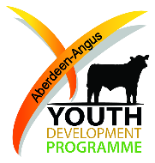

Aberdeen-Angus Cattle Society

“Thinking outside the box in a time of need”