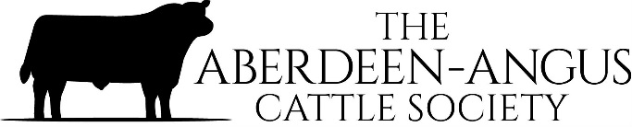

RECEIVING SOCIETY INVOICES BY EMAIL

In order to try and save on postage costs we would like to send our invoices by email. If you would like to receive your invoices by this method, then please provide Angela with the following details.

MEMBERSHIP NAME……………………………………………………………………….

MEMBERSHIP NUMBER…………………………………………………………………..

EMAIL ADDRESS………………………………………………………………………………
(of the person receiving our invoices)

Please email these details to: angela@aberdeen-angus.co.uk

Alternatively, complete and return to:
Angela Cumming, The Aberdeen-Angus Cattle Society, Pedigree House, 6 King’s Place,
Perth. PH2 8AD.

Thank you.

